Assignment: Calculate Total Target Excluding Fridays (No Marks Allocated, but highly-valued).
Background:
In many work environments, productivity targets are set to ensure that teams and individuals achieve specific goals within a certain timeframe. However, not every day is a working day; for instance, weekends and specific weekdays might be excluded due to various reasons. Understanding how to calculate adjusted targets based on actual working days is crucial in planning and evaluating performance.
Challenge:
Your task is to create a program that calculates the total target amount for a specific period, taking into account that Fridays are not considered working days. The calculation should adjust the total annual target based on the number of working days (excluding Fridays) within the specified start and end dates.
Requirements:
- Input: Your program should accept three inputs:
  - startDate (string): The start date of the period in YYYY-MM-DD format.
  - endDate (string): The end date of the period in YYYY-MM-DD format.
  - totalAnnualTarget (number): The total target for the year.
- Output: The program should output an object containing the following information:
  - The total target amount adjusted for the given period, excluding Fridays. See the bellow screenshot:
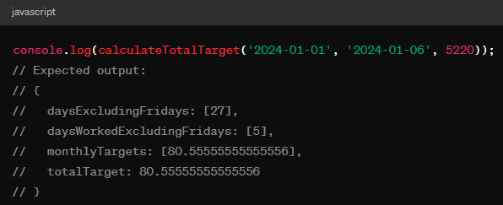
Considerations:
- How will you handle dates and calculate the duration between the start and end dates?
- How will you identify Fridays within the given period and exclude them from your calculation?
- How will you adjust the annual target based on the actual number of working days in the specified period?
Guidelines:
- You are free to choose the programming language and any libraries or tools you find appropriate for this task.
- Consider code readability, efficiency, and correctness in your solution.
- Document your approach and any assumptions you make during the process.
Evaluation Criteria:
- Correctness: Does the program accurately calculate the total target, excluding Fridays, for the given period?
- Efficiency: How efficiently does your solution handle date calculations and iterations?
- Creativity: How innovative and effective is your approach to solving the challenge?
- Documentation: Is your code well-documented, making it easy to understand your logic and approach?
Submission:
Provide your source code and any instructions needed to run your program. If you’ve written tests for your solution, include those as well.

